**WEB APPLICATION OF SNAKE GAME**

**HTML CODE:**

<!doctype html>

<html lang="en">

<head>

    <!-- Required meta tags -->

    <meta charset="utf-8">

    <meta name="viewport" content="width=device-width, initial-scale=1">

    <!-- CSS -->

    <link rel="stylesheet" href="snake.css">

    <title>Snake Game web application

    </title>

</head>

<body>

    <div class="container">

        <div class="instructions"> Use your keyboard arrows to move , start by clicking any arrow button.

        </div>

        <div class="game">

        </div>

        <div class="game_controls">

            <div class="score_container">

                Score:<span class="score">0</span>

            </div>

            <button id="restart_game" type="button">RESTART</button>

        </div>

    </div>

    <script src="snake.js"></script>

</body>

</html>

**First output srceen:**

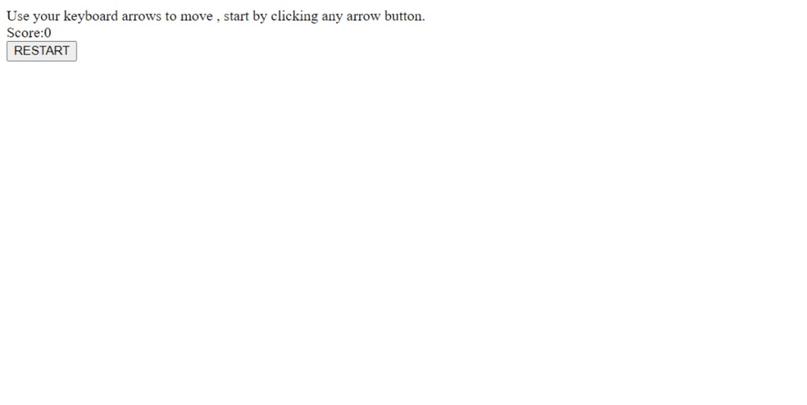

**CSS CODE:**

@import url("https://fonts.googleapis.com/css2?family=Poppins&family=Potta+One&display=swap");

* {

  margin: 0;

  padding: 0;

  box-sizing: border-box;

  font-family: "Poppins", sans-serif;

}

body {

  background: #131212;

  color: rgb(194, 74, 74);

  display: flex;

  align-items: center;

  justify-content: center;

}

html,

body {

  margin: 0;

  height: 100%;

  display: flex;

  justify-content: center;

  align-items: center;

  font-family: sans-serif;

}

.container {

  position: relative;

  padding: 20px;

}

.score_container {

  font-size: 16px;

  text-align: center;

  margin: 10px 0;

}

#restart_game {

  margin: 0 auto;

  display: block;

  padding: 9px 5px;

  background: #212121;

  color: #00ff80;

  font-weight: bold;

  border: none;

}

.title {

  font-size: 16px;

}

.game {

  height: 480px;

  width: 480px;

  background: #e0e0e0;

  margin: 0 auto;

}

.tile {

  float: left;

  margin: 0;

  content: "";

  background: #e0e0e0;

  box-sizing: border-box;

  position: relative;

  display: block;

  box-shadow: inset 0px 0px 0px 1px rgba(0, 134, 255, 0.05);

}

.body {

  background: #997b7b;

  border: 2px solid #0e0d0d;

  border-radius: 3px;

}

.head {

  background: rgb(126, 3, 3);

}

.fruit {

  background: #00b35a;

  border-radius: 5px;

}

.instructions {

  font-size: 13px;

  color: #f1f0f0;

  padding-bottom: 20px;

}

**JAVASCRIPT CODE:**

var direction;

var tilesNum = 225;

var tilesPerRow = Math.sqrt(tilesNum);

var rowStartLeft = new Array();

var rowStartTop = new Array();

var rowEndBottom = new Array();

var rowEndRight = new Array();

var emptyTiles = new Array();

var body = [3, 2, 1];

var moving;

var fruitGenerator;

var powerGenerator;

var gameDiv = document.getElementsByClassName('game')[0];

var boxDimensions = (100 / tilesPerRow).toFixed(3);

var restartButton = document.getElementById('restart_game');

var scoreSpan = document.getElementsByClassName('score')[0];

var score = 0;

var speed = 0.1;

restartButton.addEventListener("click", function () {

    restartGame();

}, false);

function createGrid() {

    for (var i = 1; i <= tilesNum; i++) {

        gameDiv.innerHTML = gameDiv.innerHTML + '<div class="tile" data-tile="' + i + '" style="width:' + boxDimensions + '%; height:' + boxDimensions + '%"></div>';

    }

}

function createBody() {

    for (var i = 1; i <= body.length; i++) {

        if (i == 3) {

            document.querySelector('[data-tile="' + i + '"]').classList.add("head", "body");

        } else if (i == 1 || i == 2) {

            document.querySelector('[data-tile="' + i + '"]').classList.add("body");

        }

    }

}

// Array consisting of upmost left boxes

for (var i = 1; i <= tilesNum; i += tilesPerRow) {

    rowStartLeft.push(i);

}

// Array consisting of upmost right boxes

for (var i = tilesPerRow; i <= tilesNum; i += tilesPerRow) {

    rowEndRight.push(i);

}

// Array consisting of upmost top boxes

for (var i = 1; i <= tilesPerRow; i += 1) {

    rowStartTop.push(i);

}

// Array consisting of upmost bottom boxes

for (var i = (tilesNum - tilesPerRow) + 1; i <= tilesNum; i += 1) {

    rowEndBottom.push(i);

}

window.addEventListener("keydown", control, false);

function control(e) {

    // RIGHT ARROW

    if (e.keyCode == "39") {

        if (direction != 'r' && direction != 'l') {

            changeDirection('r');

        }

    }

    // LEFT ARROW

    if (e.keyCode == "37") {

        if (direction != 'l' && direction != 'r') {

            changeDirection('l');

        }

    }

    // DOWN ARROW

    if (e.keyCode == "40") {

        if (direction != 'd' && direction != 'u') {

            changeDirection('d');

        }

    }

    // UP ARROW

    if (e.keyCode == "38") {

        if (direction != 'u' && direction != 'd') {

            changeDirection('u');

        }

    }

}

function changeDirection(d) {

    var directionDeciderNum,

        directionArrayInit,

        directionArrayOf;

    switch (d) {

        case "r":

            directionDeciderNum = 1;

            directionArrayInit = rowEndRight;

            directionArrayOf = rowStartLeft;

            break;

        case "l":

            directionDeciderNum = -1;

            directionArrayInit = rowStartLeft;

            directionArrayOf = rowEndRight;

            break;

        case "d":

            directionDeciderNum = tilesPerRow;

            directionArrayInit = rowEndBottom;

            directionArrayOf = rowStartTop;

            break;

        case "u":

            directionDeciderNum = -tilesPerRow;

            directionArrayInit = rowStartTop;

            directionArrayOf = rowEndBottom;

            break;

    }

    clearInterval(moving);

    moving = setInterval(function () {

        direction = d;

        var head = document.getElementsByClassName('head')[0];

        var nextTileNum = directionArrayInit.indexOf(parseInt(head.dataset.tile, 10)) > -1 ? directionArrayOf[directionArrayInit.indexOf(parseInt(head.dataset.tile, 10))] : parseInt(head.dataset.tile, 10) + directionDeciderNum;

        if (body.indexOf(nextTileNum) > -1) {

            scoreSpan.innerHTML = +score + ". GAME OVER";

            restartGame();

        } else {

            var nextTile = document.querySelector('[data-tile ="' + nextTileNum + '"]');

            var lastTile = document.querySelector('[data-tile ="' + body[body.length - 1] + '"]');

            body.unshift(nextTileNum);

            nextTile.classList.add("head", "body");

            // IF EATEN FRUIT

            if (nextTile.classList.contains('fruit')) {

                score += 1;

                scoreSpan.innerHTML = score;

                speed = score % 2 == 0 ? speed += 0.01 : speed;

                nextTile.classList.remove('fruit');

                clearInterval(fruitGenerator);

                generateFruit();

                fruitGen();

            }

            // IF JUST MOVING

            else {

                lastTile.classList.remove("body");

                body.pop();

            };

            head.classList.remove("head");

        }

    }, 10 / speed);

}

function generateFruit() {

    var rand;

    var fruit = document.getElementsByClassName('fruit')[0];

    if (fruit) {

        fruit.classList.remove('fruit');

    }

    do {

        rand = Math.floor(Math.random() * tilesNum);

    } while (body.indexOf(rand) > -1);

    document.querySelector('[data-tile ="' + rand + '"]').classList.add('fruit');

}

function fruitGen() {

    fruitGenerator = setInterval(function () {

        generateFruit();

    }, 3000)

};

function startGame() {

    createGrid();

    createBody();

    generateFruit();

}

function restartGame() {

    scoreSpan.innerHTML = +score + ". GAME OVER";

    clearInterval(fruitGenerator);

    clearInterval(moving);

    body = [3, 2, 1];

    speed = 0.08;

    score = 0;

    document.querySelector('.game').innerHTML = "";

    direction = '';

    startGame();

}

startGame();

**OVERALL OUTPUT SCREEN:**

